BI1I – PROBLEM SET 02 (90 pts)
Winter Term 2026
Released: Jan 30, 2026
Due: Feb 06, 2026 (midnight)
Om Sanan

These questions are meant to sharpen your understanding of the content discussed in class. We hope these questions are engaging enough to encourage collaboration and discussion with your fellow classmates; however, you are each expected to submit individual answer sheets, written in your own words. Please cite any outside sources that you use – at times, these questions walk through specific examples that are outside the scope of the lecture slides, so we expect you to consult textbooks and/or published works/reviews. As described in the course policies, you can NOT use ChatGPT or other AI platforms to write your answers, zero tolerance.

Problem 1: Cell Surface Receptors and Effector Molecules (54 pts)
a. In class we discussed various “cellular” defense mechanisms, which involve direct cell-to-cell interactions via cell surface receptors, and “humoral” defense mechanisms, which involve soluble molecules and certain effector molecules that travel throughout the body until they encounter specific targets. Fill out the table below with examples of cell surface receptors and effector molecules employed by the innate immune system and the adaptive immune system (as many as you can think of, but at least one in each category). (10 pts)
 | Innate Immune System | Adaptive Immune system
Cell surface receptors | Toll like receptors, C-type Receptors | Antigen receptors (i.e. TCR/BCR), many other receptors in general
Effector molecules | Cytokines, complement proteins, lysoszyme | Antibodies, T cell cytokines

b. What are the general differences between cellular and humoral response? (think about the reach and the purposes of the differing mechanisms) (4 pts)
Cellular responses need direct cell to cell contact to take effect. Their purpose is to kill infected cells or activate nearby ones (intracellularly). Humoral response uses soluble molecules that circulate generally in the bloodstream and act at a distance. Their goal is to target extracellular pathogens.
c. There also exist cytosolic receptors that live within the nuclear membrane rather than on the cell surface membrane. Why are these receptors advantageous to have? (You can look at NOD-like receptors, RIG-1/MDA-5 and/or cGAS-STING for some specific examples). (2 pts)
Cytosolic receptors are advantageous because they act as a second line of defense for detecting pathogens that have already passed through the cell membrane. They can detect viral RNA or bacterial DNA inside the cell and send distress signals accordingly.

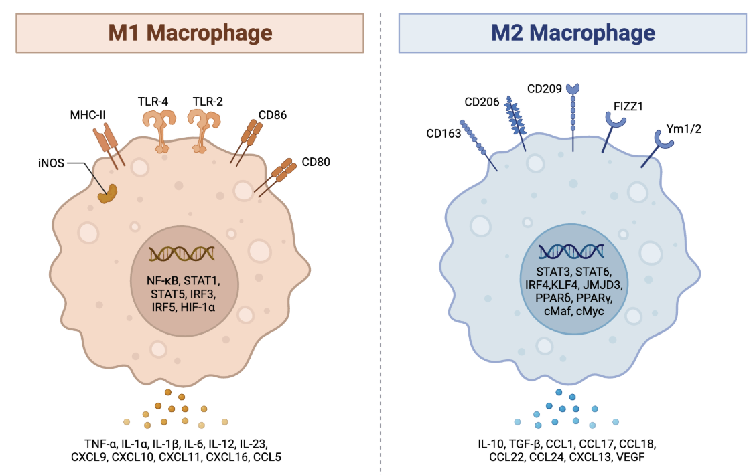
Cytokines are also widely used by all types of immune cells to amplify immunological responses and provide instructive signals to guide effector activity. Macrophages, for example, are thought to be “polarized” to specific effector subtypes depending on the cytokine(s) they are exposed to: in the presence of IFN-γ they become “pro-inflammatory” (M1) and support effector functions that kill target cells (usually via attacking cell wall/membrane) while in the presence of IL-4 and IL-13 they become “anti-inflammatory” (M2) and encourage tissue repair/wound healing mechanisms. A more detailed diagram is included below, listing the different cytokines, cell surface markers and transcription factors.

d. What are macrophages and how are they similar/different from neutrophils? (4 pts)
Macrophages are phagocytes that live in tissue. Neutrophils are first responder white blood cells diverted to the site of infection from the blood. Even though both perform similar behavior and have similar effects, neutrophils have a short lifespan and are highly destructive while macrophages have a longer lifespan and can activate adaptive immunity.

You wonder how macrophages polarize when faced with different bacterial infections and decide to do some flow cytometry experiments.

e. What does flow cytometry measure? How? (you don’t have to go into details of how the machine, but explain how the sample needs to be prepared for analysis) (2 pts)
Flow cytometry measures physical/chemical characteristics of cells such as size, complexity, fluorescence intensity. When the sample is diassociated into a suspension of individual cells, the cells get marked with antibodies lit up. Then, as each cell passes through a laser, we can use different results to analyze the properties.

f. Why would flow cytometry be useful in distinguishing between M1 and M2 macrophages? What might be some caveats to keep in mind when distinguishing these cell types in this way (think about what cell identity means and how this is defined)? (4 pts)
Flow cytometry is useful because M1 and M2 macrophages express distinct cell surface markers. Flow cytometry then allows us to quantify exactly how much of each marker is present on specific cells, letting us differentiate between populations based on their surface signature. One caveat is that the difference between M1 and M2 is not a binary variable but rather a probability distribution.

You decide to look at CD86 vs. CD206 expression with flow cytometry, comparing macrophages from a mouse model that has encountered Pneumocystis pneumonia (left plot) to macrophages from a mouse model that has encountered aspergillus fumigatus (fungal infection, right plot).
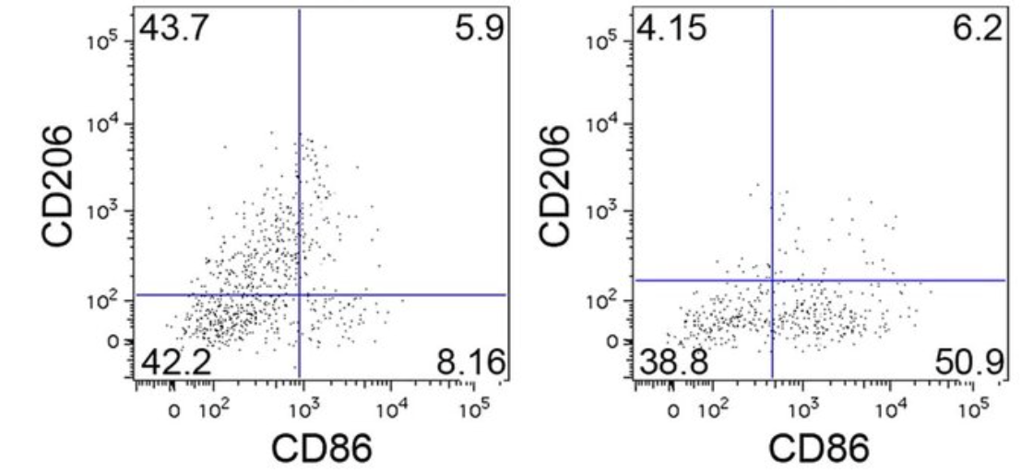

g. Based on the flow cytometry results above, how would you categorize the macrophage response elicited by Pneumocystis pneumonia and aspergillus fumigatus and why? (4 pts)
Pneumocystis pneumonia: Most cells in CD206+/CS86- section indicating a predominantly a M2 macrophage response (anti-inflammatory; immune system is geared toward tissue repair/healing).

Aspergillus fumigatus: Most cells in CD206-/CS86+ section indicating a predominantly a M1 macrophage response (inflammatory; killing response against infection).

h. What else might you try to measure to confirm the results from part f ? (4 pts)
We could analyze more M1/M2 associated surface markers or cytokine secretion.

You begin to wonder how exactly macrophages “polarize” towards one phenotype over the other. You remember talking about gene regulation and transcription factor activity in your Bi1i class, so you look into the transcription factors discussed in the diagram above. Interestingly, you find some studies done on STAT6, which have characterized this particular TF as a repressor of various pro-inflammatory gene enhancers.

i. What does a “repressor” mean in the context of transcription factor activity? (2 pt)
A repressor is a protein that binds to specific DNA sequences to inhibit or decrease the transcription of a gene.

j. What are enhancers? (2 pt)
Enhancers are short regions of DNA that can be bound by proteins to increase the likelihood of transcription of a particular gene.

Looking at a very specific example, you find a ChIP-seq dataset, which identifies sequences of the genome that are bound by your protein of interest. This ChIP-seq dataset is specifically looking at STAT6 binding in pro-inflammatory macrophages that have or have not had exposure to IL-4. The data at the IL1B gene locus, which encodes a pro-inflammatory cytokine, is shown below:

STAT6 ChIP-seq binding profile in M1 macrophages at the IL-1B locus
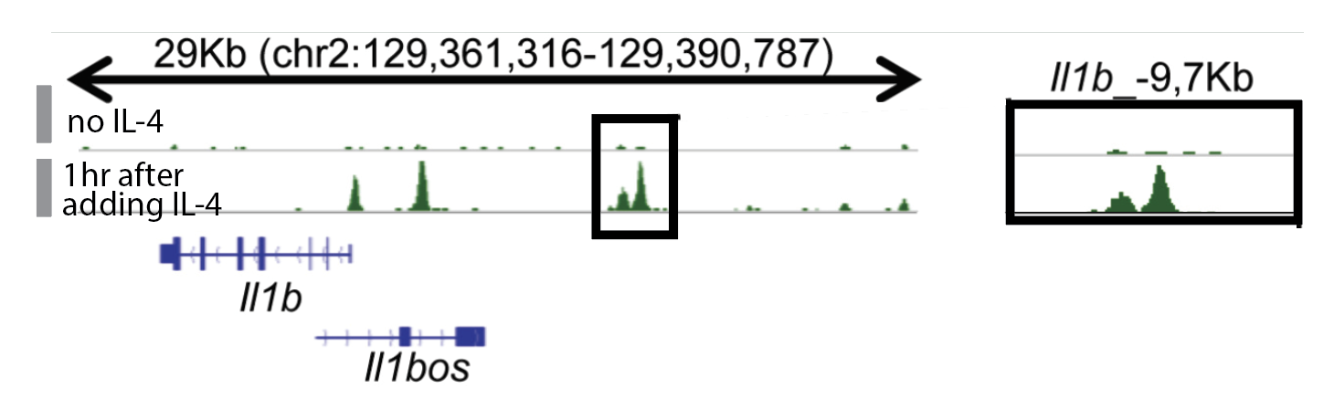

k. What does the presence of peaks mean when looking at ChIP-seq data? (2 pt)
They represent genomic reigons where some protein of interest is physically bound to the DNA.

The boxed regions along the x-axis indicate the areas along the genome that act as enhancers for the IL1B gene.

l. Which sample shows STAT6 binding to the IL1B gene enhancers? What does this mean about IL-1B expression in this sample, keeping in mind that STAT6 is a repressor? (5 pts)
The 1hr after adding IL-4 sample has peaks at the IL-1B gene enhancers while the no IL-4 sample shows no peaks. Since STAT6 is binding to the enhancers of Il1b only when IL-4 is present IL-1B expression is likely being lowered.

m. Consider the difference in binding profiles between the “no IL-4 sample and the “1hr after adding IL-4” sample. What does this binding profile tell you about the relationship between STAT6 binding and IL-4? (5 pts)
It was shown that STAT6 only binds to the Il1b enhancers in the presence of IL-4. This means IL-4 signaling is required to get STAT6 to these specific genomic sites.

n. Thinking back to the polarization phenotypes discussed earlier, how does STAT6 activity contribute to the “M2”-ness of a macrophage? What does this mean for the originally pro-inflammatory (M1) macrophages in this experiment? (4 pts)
The experiment shows that IL-4 (M2 polarizing) causes STAT6 to bind and repress Il1b. Since Il1b is a pro inflammatory gene characteristic of M1 STAT6 contributes to M2 by inactivating M1 genes.

Experiments that rely on this sort of logic are pretty common in immunology research, so it becomes important to keep track of all the variables and the relationships between each variable. You can draw diagrams or make logic tables to help keep track – feel free to fill out the table below if it is helpful for answering questions in parts l-n
 | ChIP-seq binding at IL-1B locus (peaks anywhere?) | What does this say about STAT6 binding activity? | What does this say about IL-1B expression? | What does this say about macrophage activity?
Macrophages with no-IL4 | No peaks | Inactive/not bound here | It is expressed | Pro inflammatory (M1)
Macrophages 1hr after IL4 | Yes at enhancers | Actively bound to enhancers | It is repressed | Anti inflammatory (M2)

Problem 2: A closer look at SARS-CoV-2 (36 pts)
SARS-CoV-2 is a single-stranded RNA virus, meaning that its own genome acts like mRNA in host cells. Meanwhile, HIV (recall Dr. DeLaitsch’s lecture) is also a single-stranded RNA virus but is more specifically a retrovirus: its genome encodes for reverse transcriptase, which can transcribe the virus’s RNA-based genomic material into DNA to then be integrated with the host genome.

a. How do the different replication strategies of SARS-CoV-2 and HIV impact the replication frequencies for each virus? What does this mean for host evasion? (4pts)
SARS acts directly as mRNA which makes it replicate rapidly and with high frequency. HIV is a virus that must reverse transcribe and join host DNA first, so its replication cycle is slower.
Accordingly, SARS uses speed to overwhelm the immune system before it can react and HIV hides in the genome to avoid detection.

Interestingly, SARS-CoV-2 specifically infects cells with the ACE2 receptor (mucus-secreting goblet cells in the nose, certain lung cells, etc.) by using a spike protein (S protein) expressed on the virus’s membrane. This S protein is thus used in certain COVID-19 detection tests to determine whether you have had/are currently having an immunological response to SARS-CoV-2 infection.

Many of the COVID-19 tests available are a type of lateral flow assays (LFA). These assays are rapid, paper-based point-of-care diagnostic tools used to detect either specific antigens or specific antibodies in blood, saliva, or urine samples. They are renowned for being low-cost, easy to use, and provide results in 5-30 minutes. Below is a diagram of a common type of LFA: 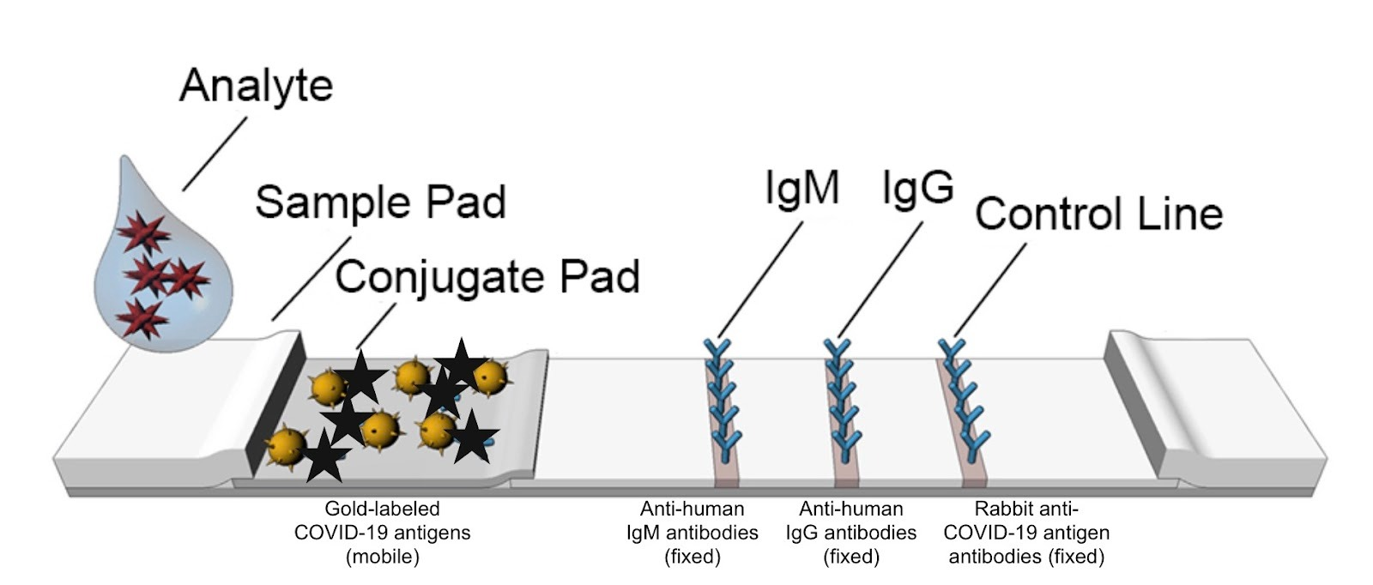

In this LFA, three different types of antibodies are applied to distinct regions of a strip of chromatography paper, labeled IgM, IgG and Control Line. Importantly, in the “conjugate pad” area there are gold nanoparticle-labelled antigens, in this case pieces of the S protein, which are mobile; once a nasal swab sample is mixed with an extraction buffer and applied to the tip of the paper strip (labeled as analyte), the sample flows by capillary action from left to right over the different regions of the assay.

b. Why does this assay use the S protein; in other words, what is this LFA trying to detect? (2 pts)
This assay uses the S protein as bait to detect host present in someone’s blood. It is determining if the patient has made an immune response to the virus.

c. What is the purpose of the immobilized IgG and IgM lines? (feel free to refer to literature and cite it accordingly to describe why both immunoglobulins are included) (4 pts)
IgM is the first antibody type made during an infection. A positive result means a recent or active infection. IgG is produced later and stats longer in the body. A positive result here means a later stage of infection or past exposure/recovery.

d. Thinking back to flow cytometry, as discussed in problem 1 parts e-h, how is the use of antibodies here similar to the use of antibodies in flow cytometry? How is it different? (4 pts)
Both use antibodies to bind to a specific target molecule. In flow cytometry, colored antibodies bind cell surface markers and in LFA antibodies are used to capture specific analytes. Hence both reply on antibody antigen specificity.
However, flow cytometry detects antibodies that are binded to the surface of cells while LFA detects soluble antibodies floating in fluid.

e. You additionally realize that the ChIP-seq experiment mentioned in problem 1 parts k-n also relied on antibodies. What was the use of antibodies in this technique? (2 pts)
Antibodies are used to pull down (I believe I found that the term for this is immunoprecipitate) the protein of interest together with the DNA fragments it’s binded to, which subsequently brings the DNA attached to that protein along with it for sequencing.

f. You start to remember that immunoglobulin can be bound to the cell surface of B cells, but in these experimental techniques, the immunoglobulin (antibodies) are freed from cell membranes and in their secreted form. Recall (i) what is the mechanism that B cells use to create secreted or membrane-bound immunoglobulin? (ii) how is this different from V(D)J recombination? (4 pts)
(i) B cells switch between BCR and antibody using alternative mRNA splicing of the heavy chain mRNA. It can be spliced to either include a transmembrane domain (which is membrane bound BCR) or a secretion tail (which is antibody). Plasma cells favor the secreted splice form.

(ii) VDJ recombination is DNA level gene rearrangement that builds the variable region during B cell development. Secreted vs membrane choice is RNA processing only after transcription and does not change antigen specificity.

Okay, after taking this detour of exploring antibody use in experimental techniques, let’s return to the original LFA discussed for COVID-19 detection.

g. How is the presence or absence of the antigen visualized? Demonstrate on the images below. (6 pts)

  - If the person is infected:
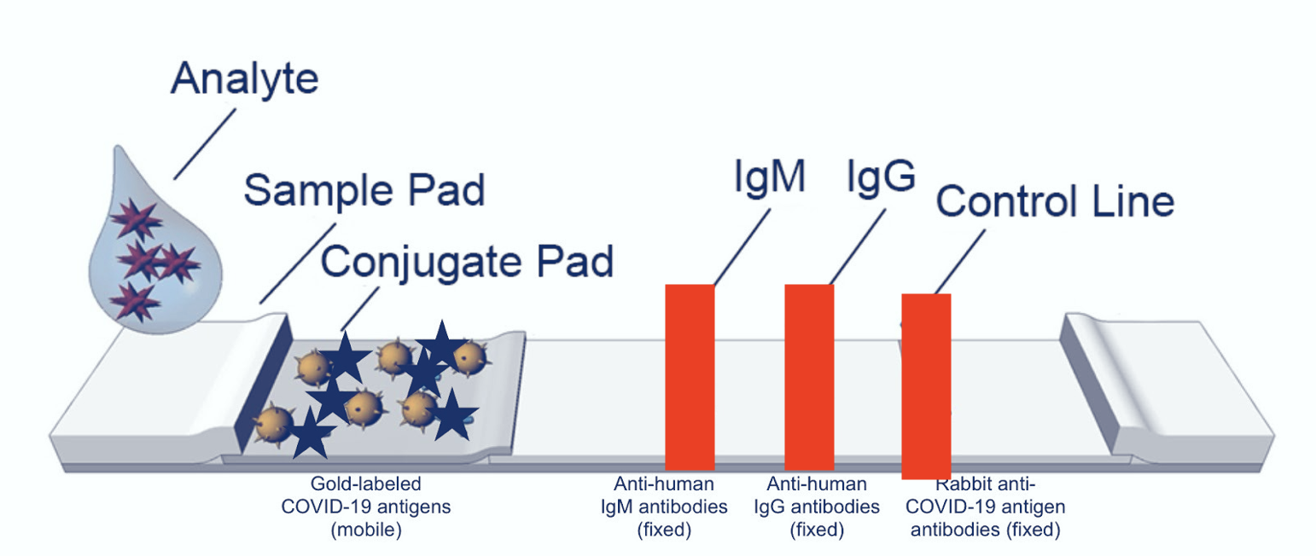
- If the person is NOT infected:
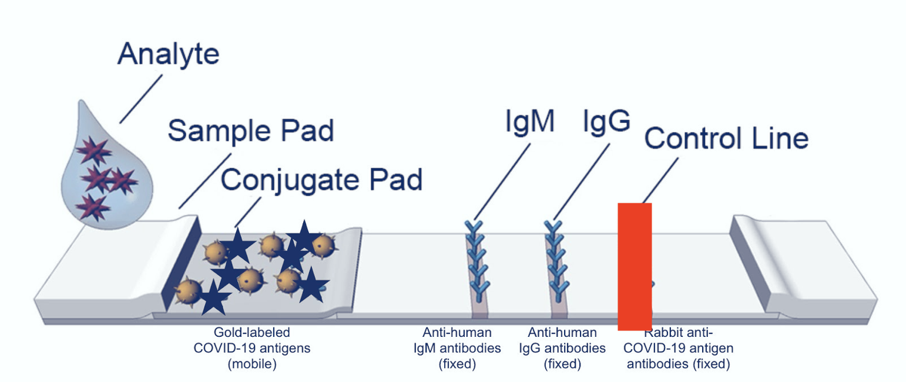
- If there’s a false positive:
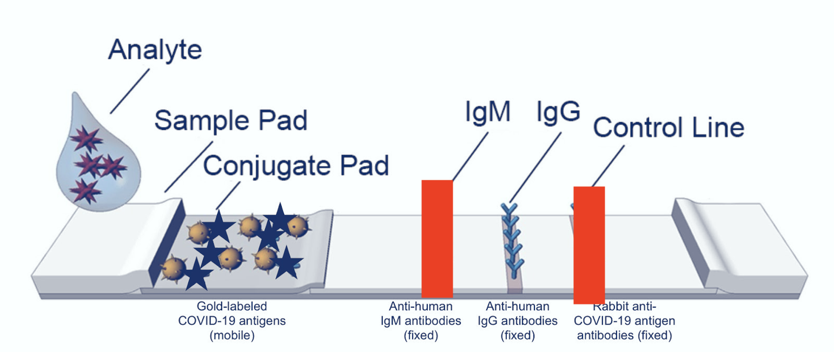

h. What is the purpose of the strip of antibodies on the right (control line)? (2 pts)
The control line should appear if the sample flowed correctly and the gold conjugate system is functioning. If no control line present, the test is invalid (even if other lines appear).

As mentioned, there are other types of LFAs that exist. One type uses gold nanoparticles that are labeled with antibodies rather than antigen.

i. If a COVID-19 test uses gold nanoparticles labeled with antibodies rather than antigen, what would this LFA be detecting? (2 pts)
Then the test would be detecting the virus itself directly from the sample instead of the host’s immune response.

Alternatively, you remember that during the pandemic, PCR tests were used to detect viral load.

j. Describe how PCR can be used as a yes/no detection test for cases like this? (What would the PCR be amplifying?) (4 pts)
PCR amplifies a specific segment of DNA exponentially. To set it up we could:
- Extract RNA from the sample
- Reverse transcribe viral RNA -> complementary DNA
- Amplify a virus specific gene segment
- If amplification signal crosses a given threshold, call it positive else negative.

k. For COVID-19 detection, what would you specifically want to target in these PCR tests? (2 pts)
We would want to target unique RNA sequences of the SARS genome, which are not found in human DNA or other common viruses.

